10.84: (a)
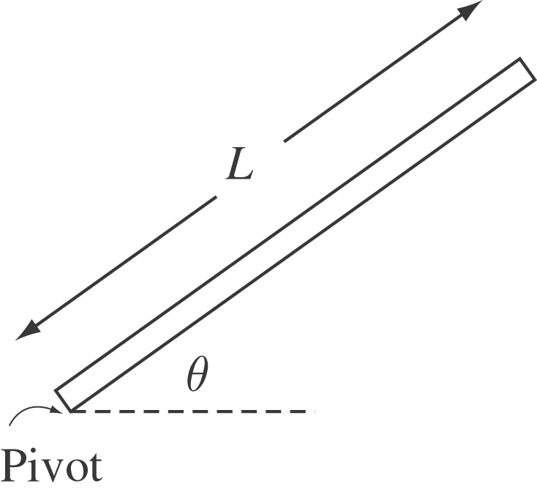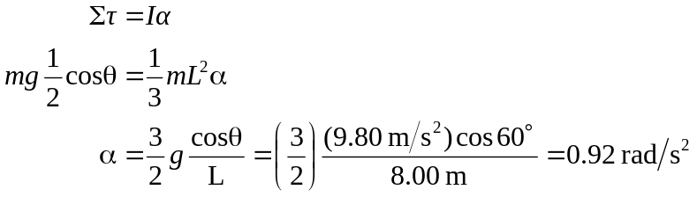

(b) As the bridge lowers, 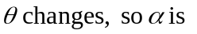not constant. Therefore Eq. (9.17) is not valid.

(c) Conservation of energy:
